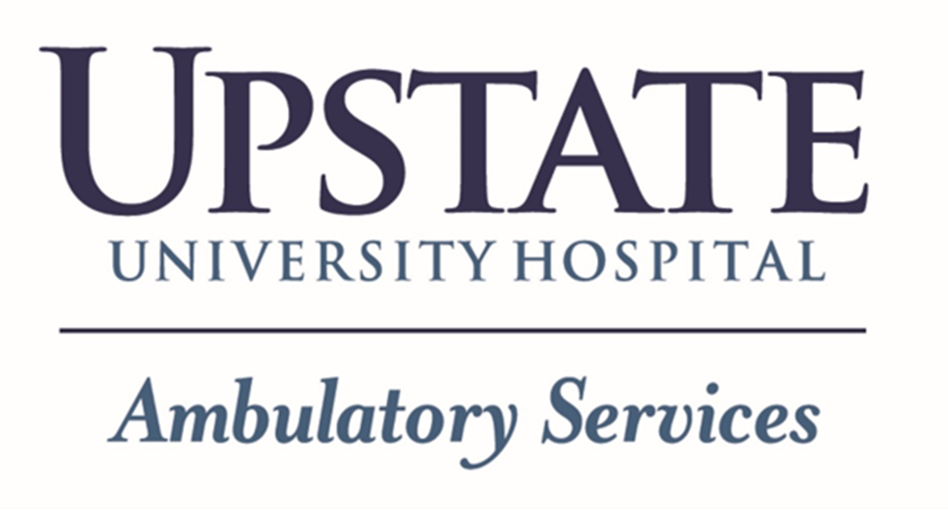

AMBULATORY SERVICES ORIENTATION

(ASO)

CLINICAL New Hire Orientation Process Checklist

Contents

Ambulatory Services Orientation (ASO) Process Overview 3

* [Ambulatory Services Orientation (ASO) Clinical New Hire Process Map](https://www.upstate.edu/nursing/documents/aso_process_map.pdf) 3
* ASO Task Force 3
* Manager role in the ASO process 3
* New Hire role in the ASO process 3

Mandatory Training *assigned by manager.* 3

* Active Shooter Training 3
* Brightspace 3
  + Brightspace self-enrollment staff instructions 4
  + Brightspace course withdrawal instructions for staff 4
* Epic-Care Ambulatory New Employee- Front Desk 4
* Epic-Care Ambulatory New Employee-Nurse/MA 100 4
* Practice Based Orientation (PBO) checklist assignment(s) in Self-Serve 4

Mandatory Training *assigned upon hire.* 4

* Brightspace New Hire Ambulatory Learning Path 5
* New Employee Orientation (NEO) full day 5
* Safe Patient Handling (SPH) 5
* Vocera Training: NEO Nursing 6
* [BLS CPR (Full and Renewal QCPR)](#_BLS_CPR_(Full) 6
* CPI Non-Violent Crisis Intervention Training 6
* Professional Development & Learning (PDL) 6

Additional Resources for Managers 6

# Ambulatory Services Orientation (ASO) Process Overview

Welcome to Ambulatory Services Orientation better known as ASO!! ASO provides a basic training plan to acclimate the new employee to the Ambulatory Services Department and to the supports available for those areas. Select the following link to view the:

[Ambulatory Services Orientation (ASO) Clinical New Hire Process Map](https://www.upstate.edu/nursing/documents/aso_process_map.pdf).

## ASO Task Force

The ASO Task Force consists of 15 members that represent the multifaceted Ambulatory Services Department. This workgroup provides recommendation for general training applicable to new hires in the Ambulatory Services Department to Ambulatory leadership and stakeholders.

## Manager role in the ASO process

The Manager is responsible to providing support for their new employee through their onboarding and orientation process. The Manager is responsible for reviewing their new employee’s training schedule Include training outlined in the in ASO Process map in your new employee training and shadow plan as appropriate. Reach out to the appropriate support area with questions when onboarding a new employee.

## New Hire role in the ASO process

The new hire is responsible for completing all training as appropriate throughout their orientation process.

# Mandatory Training *assigned by manager*:

Can schedule once new hire has an Employee ID#.

## Active Shooter Training:

Hybrid training offered through UPD; schedule follows NEO. See Upstate Announcements for details.

## [Brightspace:](https://mylearning.suny.edu/d2l/home/7462)

Asynchronous, online education and training (if prompted, select  to access Brightspace)

**Licensed Nursing staff must self-enroll for or be assigned by manager or delegate the following courses:**

* Medication Administration Exam

**Staff in areas that perform mandatory skills (Phlebotomy and/or Blood Administration) must self-enroll for or be assigned by manager or delegate for the following courses:**

* Annual Phlebotomy & Lab Collect for Nursing Staff (Online Pre-Work)
* Annual Blood Administration

**Manager Assigned Learning Paths and courses.**

* Resource for: [how_to_enroll_staff_in_courses_in_my_training.pdf (upstate.edu)](https://www-upstate-edu.libproxy.upstate.edu/hr/document/intra/how_to_enroll_staff_in_courses_in_my_training.pdf)
* Resource for: [how_to_enroll_new_hires_in_dept_learning_paths.pdf (upstate.edu)](https://www-upstate-edu.libproxy.upstate.edu/hr/document/intra/how_to_enroll_new_hires_in_dept_learning_paths.pdf)
* Submit a [Request Form - Brightspace Support For Employees (upstate.edu)](https://solutions.upstate.edu/TDClient/650/HRPortal/Requests/TicketRequests/NewForm?ID=zByGKsdB37c_&RequestorType=Service) for Coach access.

### Brightspace Course Self-Enrollment Instructions:

1. Go to Brightspace from the iPage.
2. Select “My Training” tab.
3. Select “Register for Course” from the left menu options.
4. Search for course(s) and select “Register”.
5. Once course is added to cart, click cart, and select “Proceed to Checkout”.
6. Once complete, the course will be added to the “My Training” dashboard.

*Withdraw from a Brightspace Course (staff instructions)

1. Option in "My Training" on the left-hand side of the screen
2. Click Withdraw from Course
3. Request New Drop
4. Choose the course and reason from the dropdown menu.
5. Click Save *The request will be processed within a few days*

Email Epic Training Center of Excellence at [REQAMBTRN@upstate.edu](mailto:REQAMBTRN@upstate.edu) for Epic Training questions.

## [Practice Based Orientation (PBO) checklist assignment(s) in Self-Serve:](https://selfserve.upstate.edu/ais/applications/orientation_chklists/)

Available online via Self-Serve

* [Ambulatory Services Core Practice Based Orientation: ALL CLINICAL STAFF (Licensed and Unlicensed)- Tracker Code: ORIENT-12.](https://selfserve.upstate.edu/ais/applications/orientation_chklists/print_checklist.cfm?list_id=921)

Please note: This general PBO encompasses knowledge, skills and attitudes the new hire will need to be successful in Ambulatory Services. Clinic based PBOs are highly recommended to capture the knowledge, skills and attitudes the new hire will need to be successful in their specific work area.

* [Instructions for PBO access in Self-Serve](https://www.upstate.edu/hr/document/intra/access_to_orientation_checklists.pdf) (manager and trainer access only)
* [PBO Process](https://www.upstate.edu/hr/document/pbo_algorithm.pdf)
* [Orientation Checklists in Self-Serve: Instructions for Managers and Trainers](https://www.upstate.edu/hr/document/intra/orientation_checklists_instructions_for_trainers_and_managers.pdf)
* [Department Checklists in Self-Serve: Instructions for Orientees](https://www.upstate.edu/hr/document/intra/orientation_checklists_orientees.pdf)

# Mandatory Training *assigned upon hire*:

No additional action necessary from Manager

## Brightspace: New Hire Ambulatory Clinical learning path:

Approximately 14 hours of online training. See learning path in Brightspace for more details and most recent listing of required courses.

## New Employee Orientation (NEO) full day:

In person, CAB: 0730-1200; Weiskotten Library: 1230-1600

* HR resources-CAB 0730-1200- Benefits, parking, union, etc.
* IMT resources-Weiskotten Library 1230-1330
* Brightspace education working session- Weiskotten Library 1330-1600

Email Professional Development and Learning (PD&L) at [PDLStaff@upstate.edu](mailto:PDLStaff@upstate.edu) for NEO questions.

## Safe Patient Handling (SPH):

In person, DT room 1328B: 8:00 a.m.- 10:00 a.m.

* **Staff from following clinics are currently scheduled for this training: ￼**
  + Cancer Center DT, CC, Oswego, and Verona
  + Gynecology/Oncology
* Clinical new hires from other Ambulatory areas must complete the SPH Brightspace course.

Email PD&L at [PDLStaff@upstate.edu](mailto:PDLStaff@upstate.edu) for SPH scheduling questions.

## [Epic Care Ambulatory New Employee - Front Desk](https://www-upstate-edu.libproxy.upstate.edu/pdl/intra/register/index.php?topicid=68784):

In person, Fly Road 3 consecutive days of training 8:00 a.m.-4:30 p.m.

* MOAs and Administrative new hires

Email Epic Training Center of Excellence at [REQAMBTRN@upstate.edu](mailto:REQAMBTRN@upstate.edu) for Epic Training questions.

## [Epic Care Ambulatory New Employee - Nurse/MA 100](https://www.upstate.edu/pdl/intra/register/index.php?topicid=61469):

In person, Fly Road Monday following New Employee Orientation (NEO) 8:30 a.m.-3:30 p.m.

* Licensed and Unlicensed clinical new hires

## [Vocera Training: NEO Nursing](https://www.upstate.edu/pdl/intra/register/index.php?topicid=51505):

In Person, Nappi 2151/2153 Friday following NEO 1030-1200

* Staff working in clinics that have Vocera will be scheduled for training.

Contact VOCERA SUPPORT via a Vocera badge or by calling 315-464-1400 for questions concerning Vocera training.

## [BLS CPR (Full and Renewal):](https://www-upstate-edu.libproxy.upstate.edu/pdl/intra/cpr.php)

In person, see below for details.

* [**BLS-HeartCode INITIAL/RENEWAL:**](https://www.upstate.edu/pdl/intra/register/index.php?topicid=179676)Click link for more details and for scheduling information.

Email [CPR@upstate.edu](mailto:CPR@upstate.edu) for CPR training questions.

## [CPI Non-Crisis Intervention (NCI) Training-](https://www.upstate.edu/pdl/intra/register/index.php?topicid=191481)

In Person, CC Classroom or Community Room Thursday week following NEO 10:15 a.m.-4:00 p.m.

* Includes verbal de-escalation and disengagement skills.

Email Clinical Nursing Education Team at [ClinEd@upstate.edu](mailto:ClinEd@upstate.edu) for CPI NCI training questions.

## [Professional Development and Learning (PD&L) Training](https://www-upstate-edu.libproxy.upstate.edu/hr/document/intra/pdl_classes_at_a_glance_12_15_2021.pdf):

In person, Virtual, 3-hour course offered at various times.

* [Communication Skills I: Back to Basics](https://www-upstate-edu.libproxy.upstate.edu/pdl/intra/register/index.php?topicid=7023) (scheduled within 1-3 months from hire)
* [Communication Skills II: Being More Assertive, Handling Difficult People, sand Situations with Confidence (INCE).](https://www-upstate-edu.libproxy.upstate.edu/pdl/intra/register/index.php?topicid=144415) (scheduled within 6-9 months from hire)
* [Self-Mediation of Conflict](https://www-upstate-edu.libproxy.upstate.edu/pdl/intra/register/index.php?topicid=51564) (scheduled within 3-6 months from hire)

Email Professional Development & Learning (PD&L) at [PDLStaff@upstate.edu](mailto:-%20PDLStaff@upstate.edu) with questions concerning PD&L course offerings.

# Additional Resources for Managers:

* + [AskHR](https://solutions.upstate.edu/TDClient/650/HRPortal/Home/)- For all your basic HR Questions
  + [Manager Clinic Onboarding & Orientation Guide](https://www.upstate.edu/nursing/documents/manager_ambulatory_onboarding_guide.docx)
  + [New Employee Welcome Program and Online Orientation](https://www.upstate.edu/hr/new_staff/orientation/index.php)
  + [Nursing Professional Development](https://www.upstate.edu/nursing/prof-dev/profess_dev/index.php)
  + [Nursing Business Office (NBO)](https://www.upstate.edu/nursing/prof-dev/nbo/index.php)
  + [Nurse Residency:](https://www.upstate.edu/nursing/join/nurse-residency/index.php) Required offering for new to practice GN/RNs with less than 1 year of nursing experience.
  + OneUp- Coming 2025

Last Revised: 07/2024