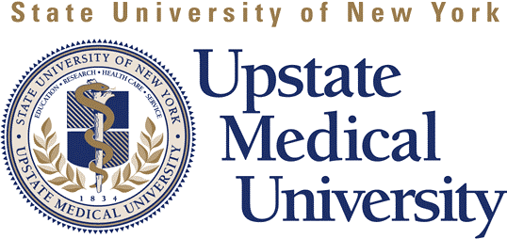

Sponsored by UPSTATE MEDICAL UNIVERSITY Office of Continuing Medical Education
and Department of Rheumatology

RHEUMATOLOGY GRAND ROUNDS

The Role of Regulatory GI Proteins in Diabetes Mellitus
March 12, 2010
7:30 - 8:30 AM
Weiskotten Hall Room 103

TARGET AUDIENCE: Physicians, Clinicians, RNs, Diabetes Educators and PAs.

LEARNING OBJECTIVES: Following this activity participants should be able to:

- xxxx
- xxxx
- xxxx

SPEAKER: John Doe, MD, MRCP Jane Smith, MD
Executive Director, Medical Affairs Professor, XYZ University
ABC University, Denver, CO Syracuse, NY

Accreditation
UPSTATE Medical University is accredited by the ACCME to provide continuing medical education for physicians.
Credit Designation
UPSTATE Medical University designates this live activity for a maximum of 1 AMA PRA Category 1 Credit(s) ™. Physicians should claim only the credit commensurate with the extent of their participation in the activity.
Disclosure Policy
To ensure balance, independence, objectivity and scientific rigor in all certified CME activity UPSTATE Medical University requires that all planners, faculty and individuals in a position to control the content of an educational activity disclose all relevant financial relationships with any commercial interest that might be perceived as a real or apparent conflict of interest. Detailed disclosures will be made in writing prior to speaker presentations.
Planner Disclosure: Drs. Jones, Smith, West and Stevens have no financial relationships with commercial interests.
Faculty Disclosure: Dr. John Doe has disclosed he is a consultant for DEF Pharmaceuticals and is on the speaker’s bureau for GHI Pharmaceuticals. Dr. Jane Smith has disclosed she has no financial relationships with commercial interests.
Americans with Disabilities Act
In accordance with the Americans with Disabilities Act, UPSTATE Medical University seeks to make this conference accessible to all. If you have a disability which might require special accommodations, please contact __________.
Commercial Support
No commercial support was received for this educational activity.

