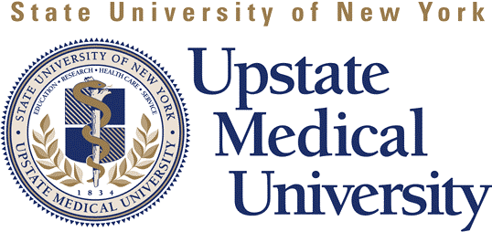
Telephone 315.464.4606
800.283.4606
Fax 315.464.4422

www.upstate.edu/cme
750 East Adams Street, WH 216
Syracuse, New York 13210

Continuing Medical Education

EXHIBITOR AGREEMENT

Activity Name:
Activity Location: |  | Date:
Exhibitor Name:
Contact Person

TERMS & CONDITIONS

As an accredited provider of continuing medical education SUNY Upstate Medical University must ensure the separation of education from promotion. CME is for educational purposes only and will not promote any products or services. The exhibitor agrees to adhere to the ACCME Standards for Commercial Support and guidelines as follows:

- Exhibitors shall not influence planning, development of, or interfere with the presentation, of any educational activity nor can it be a condition of provision of commercial support for CME activities.

- Product-promotion material or product-specific advertisement of any type is prohibited in or during CME activities. Promotional materials cannot be displayed or distributed in the educational space immediately before, during or after a CME activity.

- Exhibitors may attend the educational meeting but all promotion activities and/or discussion will only take place at the exhibit booth or outside of the meeting room.

- An exhibitor cannot be an agent providing CME activity to learners, e.g. distributing self-study CME or arranging for electronic access to CME activities.

- Acknowledgement of exhibitors will be provided to the learner by the organizers.

Agreed by Exhibitor/Vendor

Signature of Exhibiting Company Representative | Date
Signature of Program Organizer | Date

