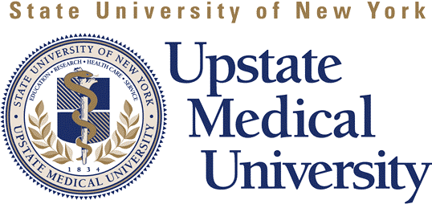
Telephone 315.464.4606
800.283.4606
Fax 315.464.4422

www.upstate.edu/cme
750 East Adams Street, WH 216
Syracuse, New York 13210

Continuing Medical Education

Verification of Speaker Disclosure and Commercial Support
for CME Activities

Please print:
Event Name:
Event ID Code: |  | Activity Date:
Presentation Title:
Speaker:
Course Director:
I witness/certify that disclosure of financial interest for the above planners and speakers was made in the following way at this CME educational activity:
Verbal - as part of introduction (included all relevant disclosure information identified on the signed SUNY Faculty Disclosure form)
Identify/describe what was disclosed:
 | Written - as part of hand-out or slide (attach documentation)
I witness/certify that commercial support was acknowledged in the following way at this CME educational activity:
Verbal - as part of introduction
Identify/describe what was disclosed:
 | Written - as part of hand-out or slide (attach documentation)
 | Verifying Individual Name:
 | Title:
 | Signature:

