**OPERATIONAL GUIDELINES: DVT/VTE Scoring and Risk Level in Pediatric Burn Patients**

The **Pediatric DVT/VTE Assessment** is documented for **patients aged 8-17**.

Pediatric burns >50% TBSA are at a higher risk for DVT’s.

**OBJECTIVE:**

In providing outstanding care to our patients at an increased risk for DVT, it is important to ensure that RNs caring for these patients have an understanding of the physicians screening assessment. In addition, providing a guide for best practice in DVT/VTE scoring in pediatric burn patients

**GUIDELINES:**

This screening tool is in the admitting resident’s workflow, and can be easily accessed at any time from the clinical overview screen. The screening questions will assess the patient risk based on the logic below, which is from the Children’s Hospital Association Solutions for Patient Safety VTE prevention bundle.

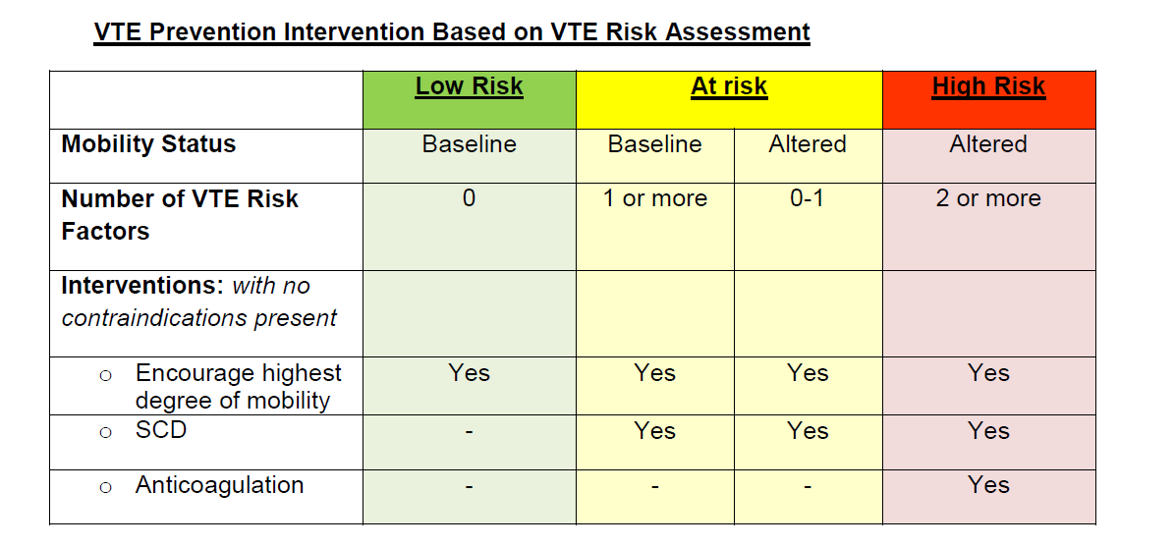

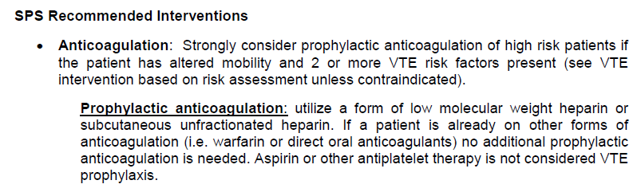

The **Pediatric DVT/VTE Assessment** is documented for **patients aged 8-17**.

1. On the assessment form, document **Trauma Patient**.

2. Additional fields cascade for **Patient Factors**, **Age**, and **GCS Score**.

3. For **Patient Factors**, indicate the relevant patient factors. Note that some factors may auto-populate based on documentation in the patient chart.

4. For **Age**, the patient **age will auto-populate** based on patient age documented in the chart.

5. The **GCS Score** (Glasgow Coma Scale) will auto-populate if the Emergency Department clinicians documented the score within the last 24 hours.

a. If the GCS Score was not completed or completed more than 24 hours ago, the score needs to be manually entered here.

6. As selections are made and documentation completed, the **Total Risk Factor Score** and **Risk Level** adjust accordingly.

This screening tool is in the admitting resident’s workflow, and can be easily accessed at any time from the clinical overview screen. The screening questions will assess the patient risk based on a clinical predictive model published by the Pacific Coast Surgical Association and approved by the Pediatric & Adult Trauma QI Teams.

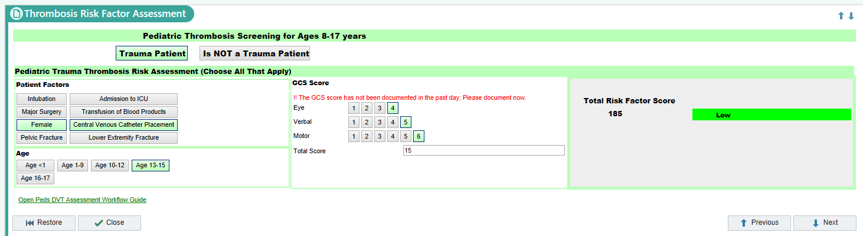

**Risk Factor Scoring**

As selections are made in the DVT/VTE Assessment form the Total Risk Factor Score auto-calculates and the Risk Level scale ranges from Low to High.

**Pediatric Trauma/Burn Risk Factor**



**Risk Factor Summary**

1. Once the DVT/VTE Assessment form is complete, the Risk Factor Summary displays. The summary serves as an overview of the patient’s overall risk level and specific point assignments for the patient’s risk factors.
2. Based upon the patients’ risk factory summary the coinciding orders for the risk factory summary will populate.
3. Prior to administration of Lovenox in pediatric burns check Anti-10A

DVT Assessment Workflow – Pediatric (8-17) <http://epic.upstate.edu/documents/intra/dvt_assessment_workflow_guide_pediatric_2016.pdf>

References:

Connelly, CR et al “A Clinical Tool for the Prediction of Venous Thromboembolism in Pediatric Trauma Patients” *JAMA Surg*. 2016;151(1):50-57. doi:10.1001/jamasurg.2015.2670

Connelly, C. R., Laird, A., Barton, J. S., Fischer, P. E., Krishnaswami, S., Schreiber, M. A., . . . Watters, J. M. (2016, January). A Clinical Tool for the Prediction of Venous Thromboembolism in Pediatric Trauma Patients. Retrieved March 23, 2018, from <https://www.ncbi.nlm.nih.gov/pubmed/26422678>